Worksheet 1.2

Student Name: Rydem UID: 25MCI10275
Branch: MCA (AI & ML) Section/Group: MAM-1 (A)
Semester: I Date of Performance: 20/08/25
Subject Name: Design and Analysis of Subject Code: 25CAP-612

Algorithms Lab

1. Aim/Overview of the practical:
Experiment-2:

Write a program to implement merge sort in python.

2. Coding :
def merge_sort(arr):
if len(arr) <= 1:
return arr

mid = len(arr) // 2

left_half = merge_sort(arr[:mid])
right_half = merge_sort(arr[mid:])

return merge(left_half, right_half)

def merge(left, right):
sorted_arr = []
i = j = 0

while i < len(left) and j < len(right):
if left[i] < right[j]:
sorted_arr.append(left[i])
i += 1
else:
sorted_arr.append(right[j])
j += 1

sorted_arr.extend(left[i:])
sorted_arr.extend(right[j:])

return sorted_arr

arr = []
num = int(input("Enter number of elements of array:"))
for i in range(num):
element= int(input(f"Enter element {i+1}:"))
arr.append(element)
print("Original array:", arr)
print("Sorted array:", merge_sort(arr))

OUTPUT:-
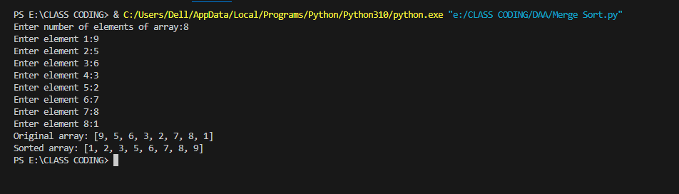

3. Learning outcomes (What I have learnt):
- Understand the working principle of the Merge Sort algorithm.
- Learn how to implement Merge Sort using divide and conquer strategy.
- Analyze the time and space complexity of Merge Sort.
- Compare Merge Sort with other sorting algorithms in terms of efficiency.
- Develop problem-solving skills using divide-and-conquer techniques.

